Part 1 – Schema Design & Database Build (30 pts)
A. Conceptual → logical mapping (10 pts)
• Final ER diagram with entities, relationships, PKs, FKs.
Entities
The final schema contains three normalized entities:
- dogs – the central fact table containing each licensed dog record.
- breeds – lookup table of unique dog breeds.
- zipcodes – lookup table of unique NYC ZIP codes.
Primary Keys:
Each entity includes a primary key that uniquely identifies every row:
- breed_id (in breeds) is a primary key due to each unique breed gets its own identifier.
- zip_id (in zipcodes) is a primary key as each unique ZIP code gets an ID (5-digit ZIPS are repeated across many dogs).
- dog_id (in dogs) is a primary key as each dog license gets its own row.
Foreign Keys:
The dogs table includes two foreign keys that link to the lookup tables:
- dogs.breed_id → breeds.breed_id
This foreign key links each dog to its corresponding breed in the breeds table.
- dogs.zip_id → zipcodes.zip_id
This foreign key links each dog to the ZIP code where it is registered, stored in the zipcodes table.
- These foreign keys enforce referential integrity across the schema.
Relationships:
The schema includes two one-to-many relationships
1. A breed can be associated with many dogs,
but each dog has one breed.
- Relationship: dogs.breed_id → breeds.breed_id
2. A ZIP code can contain many dogs,
but each dog belongs to one ZIP code.
- Relationship: dogs.zip_id → zipcodes.zip_id
These establish a classic star schema with dogs as the fact table and breeds and zipcodes as dimension/lookup tables.
Notes on Schema Quality
- The design is fully normalized (3NF): no repeating groups or duplicated attributes.
- Lookup tables eliminate redundant text values (breeds, ZIP codes).
- Foreign keys enforce referential integrity.
- A composite unique constraint on dogs prevents duplicate ETL inserts.
- Indexed attributes (breed_id, zip_id, extract_year) support performance requirements for analytics.
Entity-Relationship Diagram from pgAdmin 4
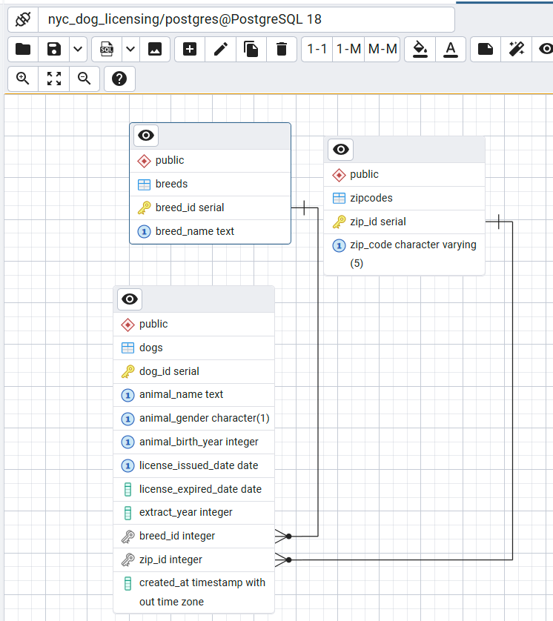

B. SQL DDL script
• CREATE TABLE statements with constraints & appropriate data types.

-- FULL DATABASE RESET (for verification/trial runs)

DROP TABLE IF EXISTS dogs CASCADE;
DROP TABLE IF EXISTS zipcodes CASCADE;
DROP TABLE IF EXISTS breeds CASCADE;

-- LOOKUP TABLE: Breeds

CREATE TABLE breeds (
breed_id SERIAL PRIMARY KEY,
breed_name TEXT NOT NULL UNIQUE
);

-- LOOKUP TABLE: Zip Codes

CREATE TABLE zipcodes (
zip_id SERIAL PRIMARY KEY,
zip_code VARCHAR(5) NOT NULL UNIQUE,
CONSTRAINT zip_format CHECK (zip_code ~ '^[0-9]{5}$')
);

-- FACT TABLE: Dogs

CREATE TABLE dogs (
dog_id SERIAL PRIMARY KEY,

animal_name TEXT NOT NULL, -- Will clean data first so no problem
animal_gender CHAR(1),
animal_birth_year INT,
license_issued_date DATE NOT NULL,
license_expired_date DATE,
extract_year INT,

breed_id INT NOT NULL REFERENCES breeds(breed_id),
zip_id INT NOT NULL REFERENCES zipcodes(zip_id),

-- Prevent duplicate records when loading ETL batches
CONSTRAINT unique_dog_record UNIQUE (
animal_name,
animal_gender,
animal_birth_year,
license_issued_date,
breed_id,
zip_id
)
);

-- INDEXES FOR PERFORMANCE

-- (1) Optimizes breed-level filtering, grouping, frequency counts
CREATE INDEX idx_dogs_breed_id ON dogs(breed_id);

-- (2) Speeds up geographic analysis (ZIP-level distribution)
CREATE INDEX idx_dogs_zip_id ON dogs(zip_id);

-- (3) Critical for time-series reporting (licenses per year)
CREATE INDEX idx_dogs_extract_year ON dogs(extract_year);

-- DATA QUALITY CONSTRAINTS
-- ========================

-- Ensure breed names are not empty
ALTER TABLE breeds
ADD CONSTRAINT breed_name_not_empty
CHECK (breed_name <> '' AND breed_name IS NOT NULL);

-- Only allow M, F, or U
ALTER TABLE dogs
ADD CONSTRAINT valid_gender
CHECK (animal_gender IN ('M', 'F', 'U'));

-- Birth years must be realistic
ALTER TABLE dogs
ADD CONSTRAINT valid_birth_year
CHECK (animal_birth_year BETWEEN 1990 AND EXTRACT(YEAR FROM CURRENT_DATE));

-- Issued date must be <= expired date (allow null expiration)
ALTER TABLE dogs
ADD CONSTRAINT dates_chronological
CHECK (
license_expired_date IS NULL
OR license_issued_date <= license_expired_date
);

-- ADDITIONAL FIELDS / INDEXES
-- ===========================

-- Audit timestamp
ALTER TABLE dogs
ADD COLUMN created_at TIMESTAMP DEFAULT CURRENT_TIMESTAMP;

-- Combined index for date-range queries
CREATE INDEX idx_dogs_license_dates
ON dogs(license_issued_date, license_expired_date);

-- DOCUMENTATION COMMENTS
-- ======================
COMMENT ON TABLE dogs
IS 'Core fact table containing licensed dog records in NYC';

COMMENT ON COLUMN dogs.extract_year
IS 'Year when this record was extracted from the source dataset';

COMMENT ON TABLE breeds
IS 'Lookup table for dog breeds, normalized to prevent duplication';

COMMENT ON TABLE zipcodes
IS 'Lookup table for 5-digit NYC ZIP codes';

-- END OF SCHEMA
• 2+ indexes and justification.
Justification: To speed up the types of queries I knew I would be running in this project, I created three indexes on the dogs table. Since this is the largest table in the schema and almost all analysis work revolves around it, adding a few targeted indexes helps avoid full-table scans and makes grouping and filtering noticeably faster.
The first index is on dogs.breed_id. I added this because a lot of the analysis for the NYC dog dataset involves looking at breed popularity, counting how many dogs belong to each breed, or comparing breeds across different areas. Queries like GROUP BY breed_id or joining back to the breeds table benefit directly from this index, since PostgreSQL can jump straight to the matching rows instead of scanning everything.
The second index is on dogs.zip_id. Most of the geographic analysis in this dataset is based on ZIP code, and many queries filter by ZIP or break down results by area. Because ZIP codes repeat across thousands of dogs, having an index here makes it much faster to pull all dogs from a specific neighborhood or to run any kind of location-based reporting.
The third index is on dogs.extract_year. This field is used for time-series trends, like counting how many licenses were issued each year or comparing activity across years. Since year-based filtering and GROUP BY extract_year are common operations, indexing this column reduces execution time for those queries.
Overall, these indexes help optimize the read-heavy nature of this project. They speed up the most common analytical queries I need for the assignment, especially the ones involving grouping, filtering, and joining without adding unnecessary overhead to the database.

C. Data-volume sanity check
Output Below From Beginning:
Total rows: 722864
----------------------------------------
NULL counts per column:
AnimalName 1810
AnimalGender 21
AnimalBirthYear 30
BreedName 0
ZipCode 9
LicenseIssuedDate 0
LicenseExpiredDate 82
Extract Year 0
dtype: int64
----------------------------------------
Invalid value checks:
Invalid birth years: 37
Missing ZIP codes: 9
Missing issue dates: 0
Missing expiration dates: 82
Data-volume Sanity Check after:
===================================================
DATA-VOLUME SANITY CHECK (POST ETL)
===================================================
Rows prepared for DB insert: 614,980
NULL counts (final df_sql):
animal_name 0
animal_gender 0
animal_birth_year 130
license_issued_date 0
license_expired_date 49
extract_year 0
breed_id 0
zip_id 0
dtype: int64
----------------------------------------
Invalid (removed) birth years: 0
Missing ZIP foreign keys: 0
Missing Breed foreign keys: 0
Missing license_issued_date: 0
Remaining duplicates in df_sql: 0
Records with NULL birth year: 130
Records with expiration < issued date: 0

